To begin, I started out with a dataset from Kaggle. The steps that went into the analysis were as follows:

DATA CLEANING AND ORGANIZATION

1. Open and explore the dataset in MS-Excel.

2. Create a new sheet copying the data from the raw data to keep the original data intact.

3. Clean the data such as removing duplicates and filter for blank fields if any.

4. Create new sheets for pivot tables and visualizations for dashboards.

DATA ANALYSIS

5. After going through the entire dataset the questions that I was able to come up with were as follows as well as the analysis:

i) Europe has been said to have a lower salary compared to than that of North America. Is it true? In what region do people make more money?

- After analysis, we found that Europe infact does have lower salary than North America.

Europe- $40,900

North America- $62,755

ii) In which region do people own more homes? How does this vary across the region in the data? How are occupation and pay related to individuals owning homes?

- After analysis, we found that North Americans own the most homes with a total of 72% owners. Europe comes in second with 65% and Pacific coming in at third with 63%.

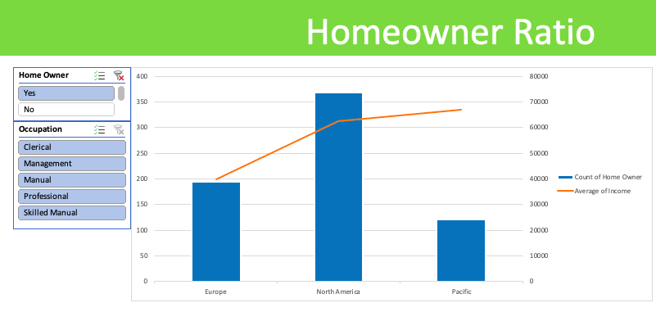

iii) Europe is said to be more affordable than North America despite their lower wages. Does that mean their system trumps North America's? How their occupation is proportional to if they own homes across Europe? Do Europeans despite having lower wages, are able to afford a home compared to their North American counterparts?

- After analysis, we found that Europe is infact affordable than the other two. In hindsight, the above result we get shows those with higher average income do own homes but despite that Europe with only 40k average income has 65% of homeowners. As we dug deeper, we found out that out of the 194 of the European homeowners, 139/194 (72%) of them were involved in clerical or manual work with an average income of about 16k compared to 6.5% (24 out of 368) of North American homeowners with about 22k average income. The majority homeowners (342/368) in North America had an average income of more than 66k.

iv) Is Europe the most bike-friendly continent?

The steps that went into deducing the result were as follows:

- While the total number of cars per person was provided, so was not the case for bikes which only had Yes/No fields. To bring that to numbers, I added a column that gave out the total number of bike purchases

assuming one yes equaling one bike per person.

- The updated data then was plotted into a pivot table and a bar graph which gave us the following numbers

i) Europe had 148 bikes in total to 316 cars --> ~1:2 bikes to car ratio

ii) North America had 220 bikes to 768 cars --> ~1:4 bikes to car ratio

iii) Pacific had 113 bikes in total to 358 cars --> ~ 1:3 bikes to car ratio

The above result shows us that Europe in fact is more bike-friendly than North America than the Pacific.

v) Gender pay gap has always been an issue of paramount importance. Do both men and women have the same average income for the same kind of jobs? How does this vary across the region?

- The average income for men is more than that for women across all regions combined and individually.

